1. First make a simliar configuration by connecting pc’s to switches

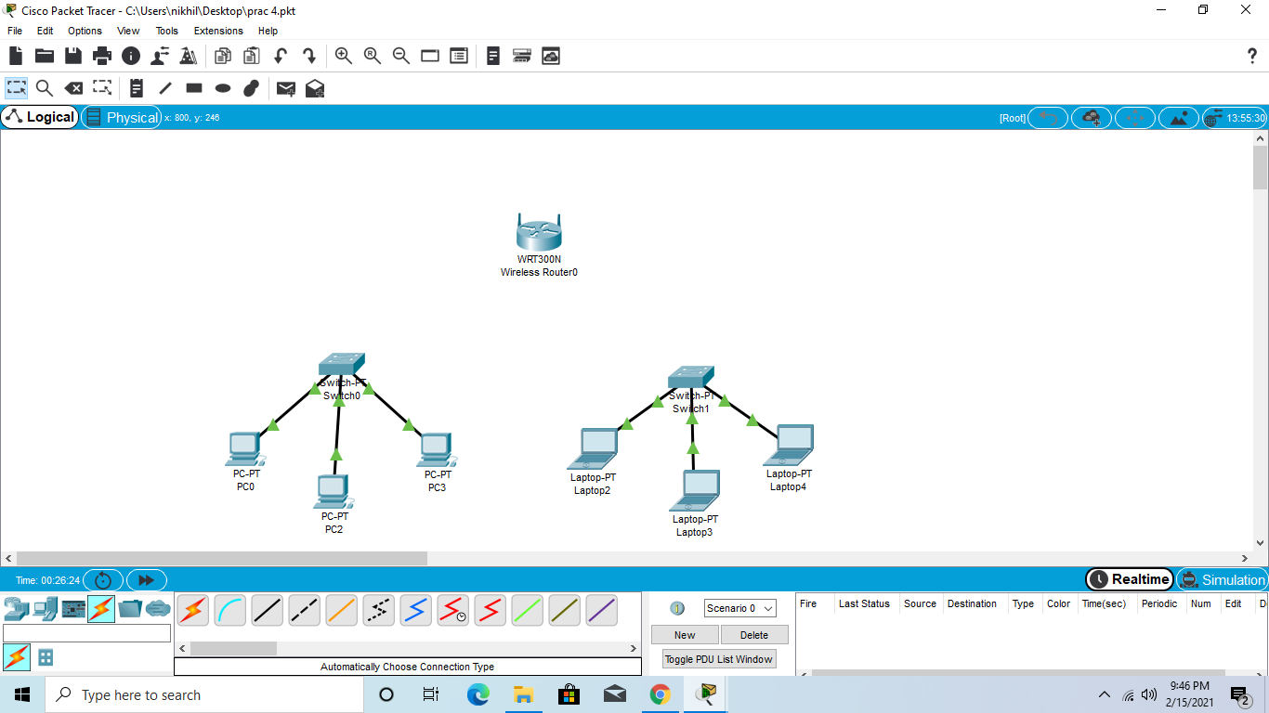

1. Now configure by adding Wep key in config>wireless for the router

